**OOP QUIZ**

1 - Write the code to create (instanciate) an object Employee "**ronan**”, from "**paris**", with **0 year** in the company

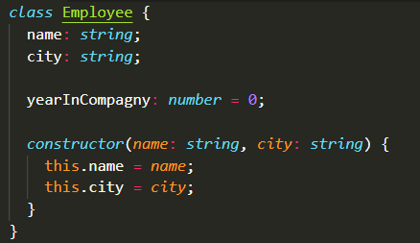

**Answer:**

|  |
| --- |
|  |

2- Write the code to create (instanciate) an object Employee "sovanda" , from "chacago ", with 3 yeasr in the compagny



**Answer:**

|  |
| --- |
|  |

3- What will this code display?

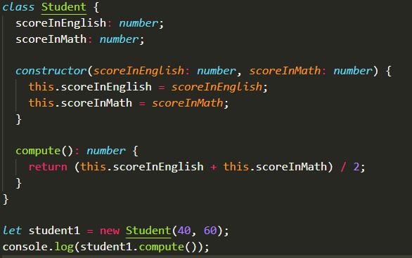

Answer:

|  |
| --- |
|  |

4. Create constructor(width,height) of the class Box and implement function getArea and getPerimeter

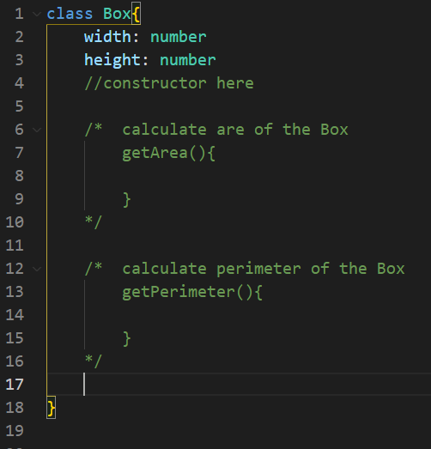

* Create constructor

|  |
| --- |
|  |

* getArea function

|  |
| --- |
|  |

* getPerimeter function

|  |
| --- |
|  |

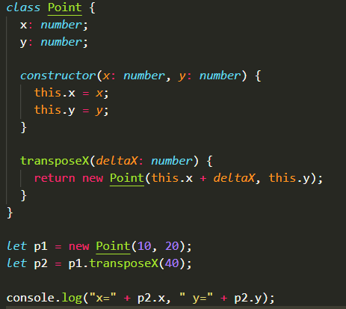5- What will be printed on console after this code execution?

**Answer:**

|  |
| --- |
|  |